Dear parents,
Due to the Covid-19 pandemic, schools will be closed (at least) until November 30.
What will my child do from today until November 30?
Until then, students will take synchronous distance learning (compulsory) through the Webex Meetings platform (live lesson).
- Kindergarten and Primary School students from 14:00 to 17:00.
- Junior High and High school students from 08:15 to 14:00.
You do not need to install anything to log to it.
To get your child involved in the lesson via Webex:
- Come in contact with your school’s teacher or school principal (if needed, ask for help from the support service)
- Request the school curriculum along with the teachers' links,
- Checkthe day and time in the program and log into the respective lesson each time.
Example: Monday, 1st hour, Mathematics (Teacher George), teacher George’s link
Due to strain, the connection may not be possible for you or the teachers. Try again.
What else should I keep in mind?
It is possible that the Ministry of Education will start in a short period of time asynchronous distance teaching as well, on the e-me and e-class platforms.
In order for your child to participate in the lesson vie e-me and e-class:
- Create, if you do not have one, an email account,
- Ask the school to enroll your child in the Pan-Hellenic School Network.
If the school does not do the registration:
- Ask the school for the Student’s Registration Number,
- Register your child in the Pan-Hellenic School Network here with the help of the support service or by following the instructions below,
- Be informed from the school about the platform chosen by the teachers (e-me or e-class) and enter the respective platforms with your passwords to activate your account.
When the lessons start on these platforms, sign in to see the invitation that the teachers will have sent you for your class’s lessons.

INSTRUCTIONS FOR REGISTRATION IN THE PANHELLENIC SCHOOL NETWORK
The language of completion must be the same as the language of enrollment in the school. Try Latin or Greek characters.

Step 1 | 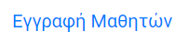  Student registration
Step 2 | 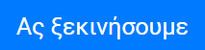  Let’s start
Step 3  Fill in the order:  - Student’s Name/ Όνομα μαθητή  - Student’s surname/ Επίθετο μαθητή  - Date of birth (Day-Month-Year)/Ημερομηνία γέννησης (Μέρα- Μήνας- Έτος)  - School/Σχολείο  - Grade/Τάξη  - Class division/Τμήμα | 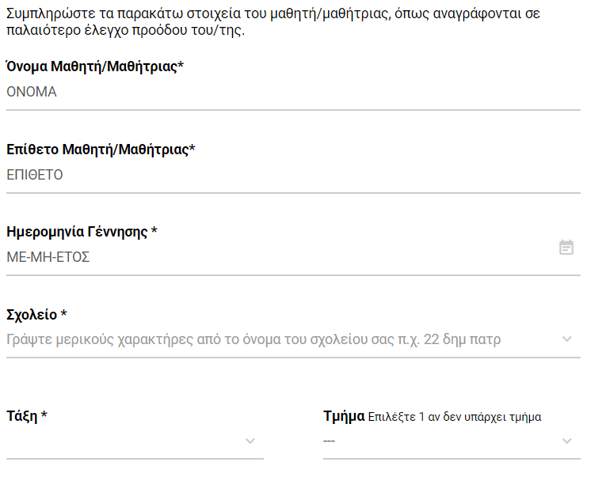
Step 4  Fill in order:  - Student’s registration number/Αριθμός μητρώου μαθητή  - Parent’s Name and surname /Ονοματεπώνυμο γονέα  - Parent’s email/Email γονέα  - Parent’s cell-phone number /Κινητό τηλέφωνο γονέα  - Enter the password in the last two boxes (7 to 16 characters, lowercase Latin, at least one uppercase or lowercase number, at least one symbol! @ $ -)  Password/ Κωδικός πρόσβασης  Retype your password /Δώστε ξανά το κωδικό | 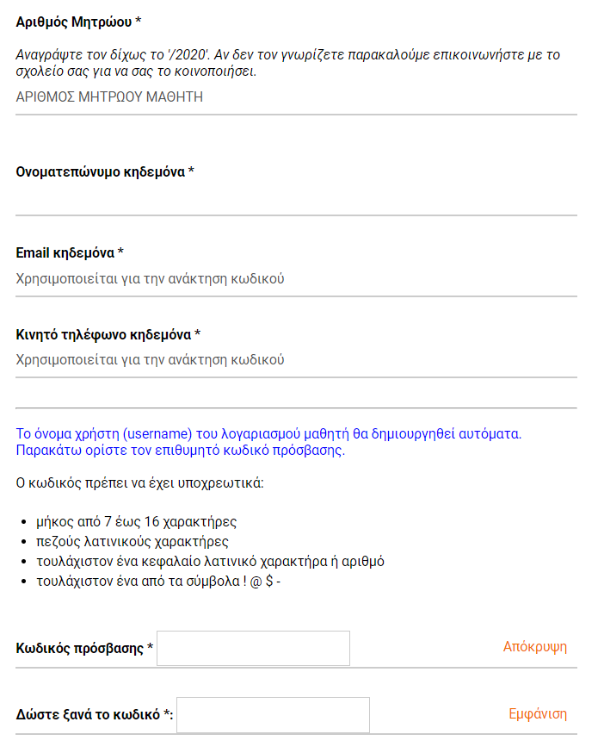

Step 5  - Click on the box/Κλικ στο κουτάκι  - Click «Next» /Κλικ στο «Επόμενο» | 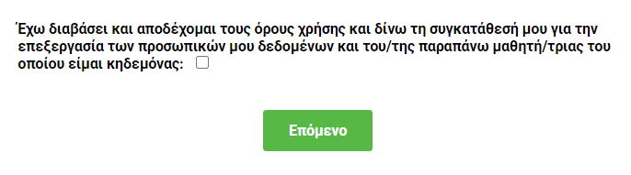
Step 6  Your username (όνομα χρήστη) and password (κωδικός πρόσβασης) are displayed on the screen.  Make a note of them and keep them in a safe place.  At the same time these data will be sent to your email. | 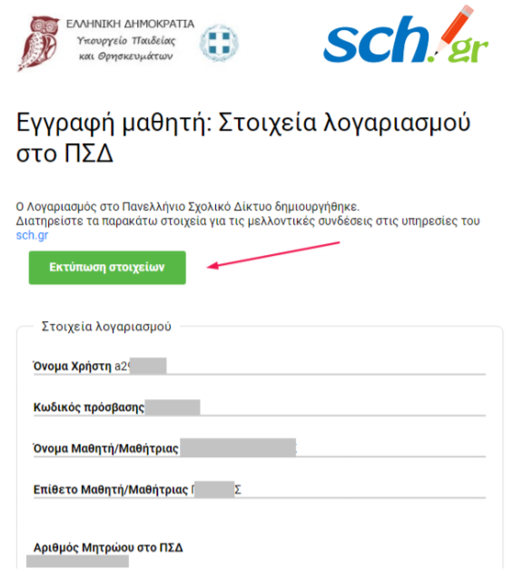

See here the instructions from the Ministry of Education and Religions.

